Remaining Bugs

- Log into app and click the pencil icon from the homepage of the app, then click ‘LINK’ you will need to create a link post by filling in a title where it says ‘Some interesting title’ and also if you click were it says ‘http://’ the app will allow you to create and insert a link there. Once those two fields have been filled in there is a small arrow next to where you entered your title, If you click the small arrow it will display a drop down menu where you will see a page called ‘Title editor’ If you click ‘Title editor’ you will go to a page where there is two fields that need filling in, the first field is called ‘Stack title’ and the second field is called ‘Category’ Once you have filled these two fields in you need to click back on the drop down menu and you will see another page called ‘Preview’ If you click ‘Preview’ this will take you in to preview mode, you will see 7 lines, if you click the first purple line you will see your link displayed in preview mode. Now click your link and you will see that the link opens within the application. We don’t want external links to open in the app we want links to open on an external web browser while our app stays open in the background – This is first bug.
Once you have clicked the first purple line in preview mode you will see a button in the bottom left called ‘Push back’ If you click this button you will be redirected to the 7 lines page again still in preview mode . On the lines page at the bottom there is a button called ‘COLLAPSE’ if you click the ‘COLLAPSE’ button you will be redirected back to the editor page where you started creating this link.
Now when you are back on the editor page again if you click ‘POST’ in the top right corner, your post will be published to the homepage of our app. Once you have clicked ‘POST’ you will be redirected to the homepage and if you click your post from the homepage and you click the first purple line you should be able to view the link you have just created but no link is being display and also there is broken image showing which shouldn’t be there because we never uploaded an image so these two issues need sorting out. This is second bug
- From the homepage of the app if you click the pencil icon again and follow the same steps mentioned in bug number 1 for creating a link post, once you have created your link post, if you click the arrow next to where it says ‘Unamed line’ there is another page called ‘’New line’ If you click ‘New line’ it will bring up a purple bar at the bottom of the screen, from here if you click the ‘IMAGE’ button you will then be redirected to the ‘Image Post’ page where you will see two options, ‘CAMERA’ & ‘LIBRARY’ so first upload a picture taken by your phones camera, when the image is uploading there is a blue loading bar displayed at the top of the page, please wait until the blue loading bar is complete as that signifies the image has finished uploading. Once the image has finished uploading you need to fill in a title where it says ‘Some interesting title’ and then click the small arrow next to the title you just entered and select ‘New line’ from the drop down menu and select ‘IMAGE’ again but this time upload a picture from your phones ‘LIBRARY’ instead and again fill out a title for your second image where it says ‘Some interesting title’.

Once your second image has finished uploading you will have now created two separate image posts that you can see in the drop down menu if you click the small arrow next to where your image title is. If you switch between the two images posts you will see that it is loading the same image for both image posts which is wrong. Remember we uploaded two different images one from our camera and the other from our library so this issue needs fixing, see screenshots below.

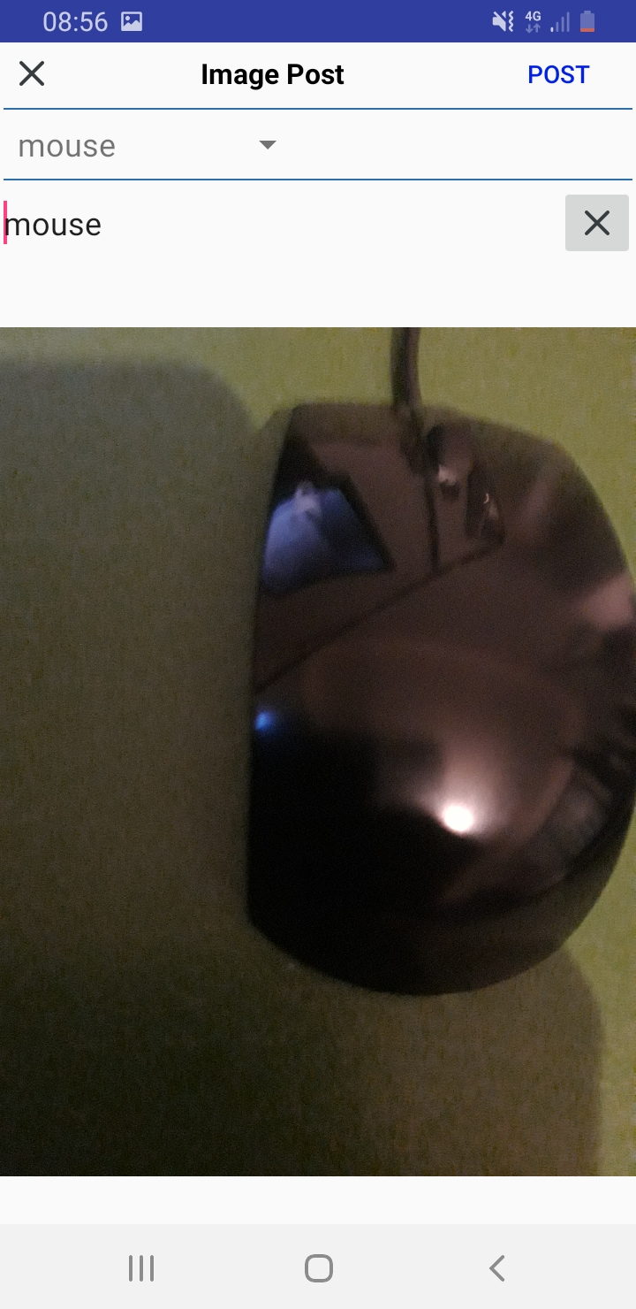

This was the original image above I took with my phones camera of a mouse. On the second image post I created I uploaded an image from my phones library of a computer desk, see screenshot below.

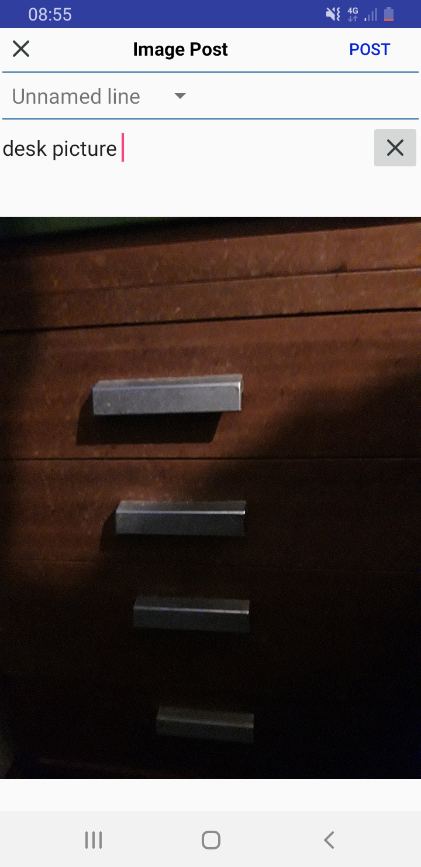

When I first selected the desk image from my phone library, while the image was uploading It was displaying the correct image but it was after the image had finished uploading and I started switching between both image post pages that it started loading the same image on both pages. – This is third bug

- Bug four is a continuation of the third bug above. So far you have created a ‘LINK’ post and two ‘IMAGE’ posts, now if you continue and click the ‘New Line’ page again from the drop down menu and select ‘Video’ and upload a video from your ‘CAMERA’ and create a title for it and then select ‘New line’ again and select ‘VIDEO’ but this time upload a video from your ‘LIABRARY’ and fill in a title. Once both videos have been uploaded if you switch between both video pages you will see similar to bug 3 it displays the same video on both pages which it should not be doing so this needs fixing. - This is bug 4

- If you click the drop down menu again from your video post page and select ‘New line’ again and select ‘TEXT’ You will then be redirected to the text post page, if you click the ‘link icon’ in the bottom left corner and create a link and click ‘OK’ afterwards, once you click on the link you have just created for some reason you are unable to click off it, it just keeps highlighting and you are unable to click off the link or type anything on the same line as the link so this needs fixing. – This is bug five

Continuing from bug number 5 you should still be on the ‘Text Post’ page which looks like this see screenshot below:

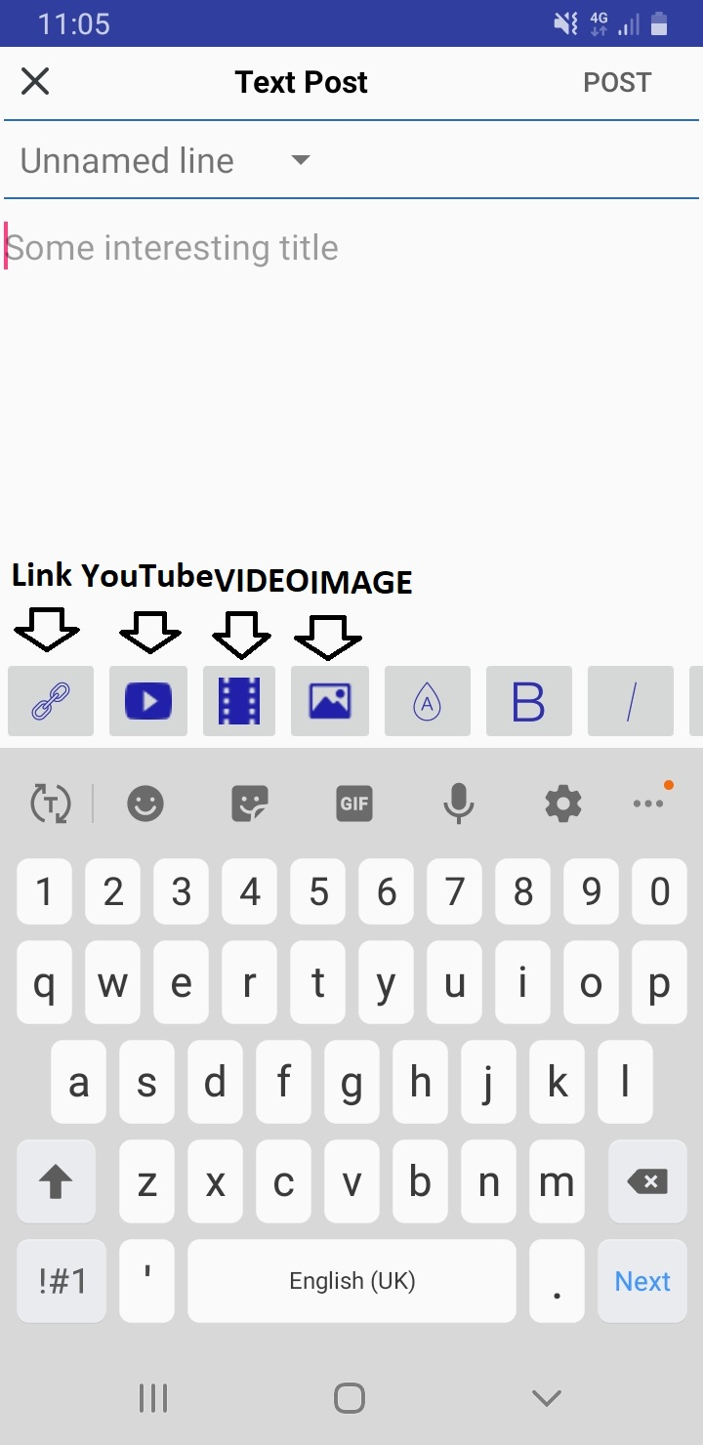

Now you need to click the youtube icon and insert a youtube video link and click ok. After you click ok this error message is displayed on screen please see screenshot below:

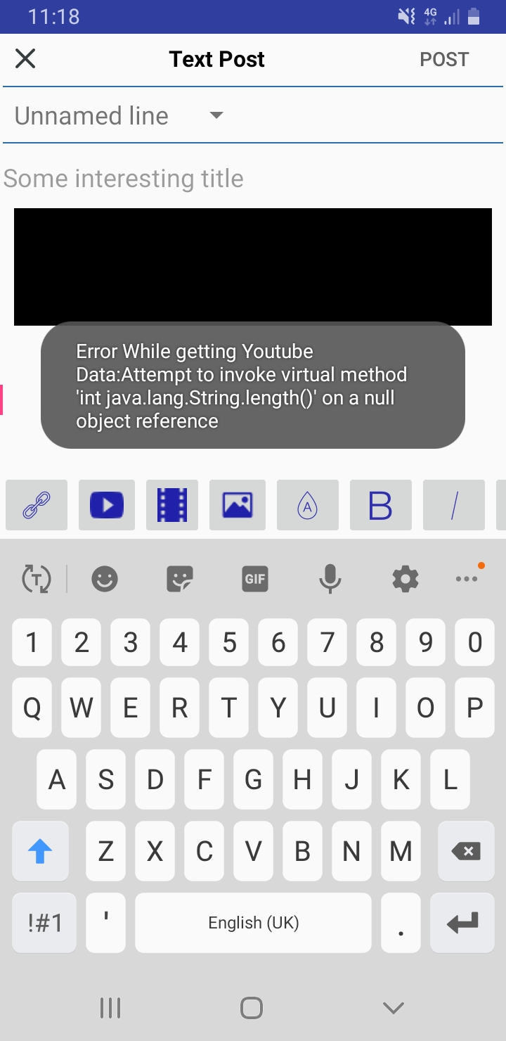

This is bug six

At this stage you will have created a link and inserted a YouTube video in the same text post. Now you need to upload a video by clicking the video icon and selecting a video to upload from either your library or camera and wait until the blue loading bar is finished. Then you will need to select the image icon and upload an image either from your phones library or. When the image has finished uploading if you click the small arrow near the text post title the drop down menu will be displayed and you need to click ‘Preview’ What should happen when you click preview is you should be redirected to the preview page where you can your posts that you have just created, however at the moment when you click ‘Preview’ a message comes up on the page that says ‘Saving’ and then another message after that says ‘Stack updated successfully’ and then you are not redirected to the preview page you just stay on the same and nothing happens. Please see the two screenshots below:

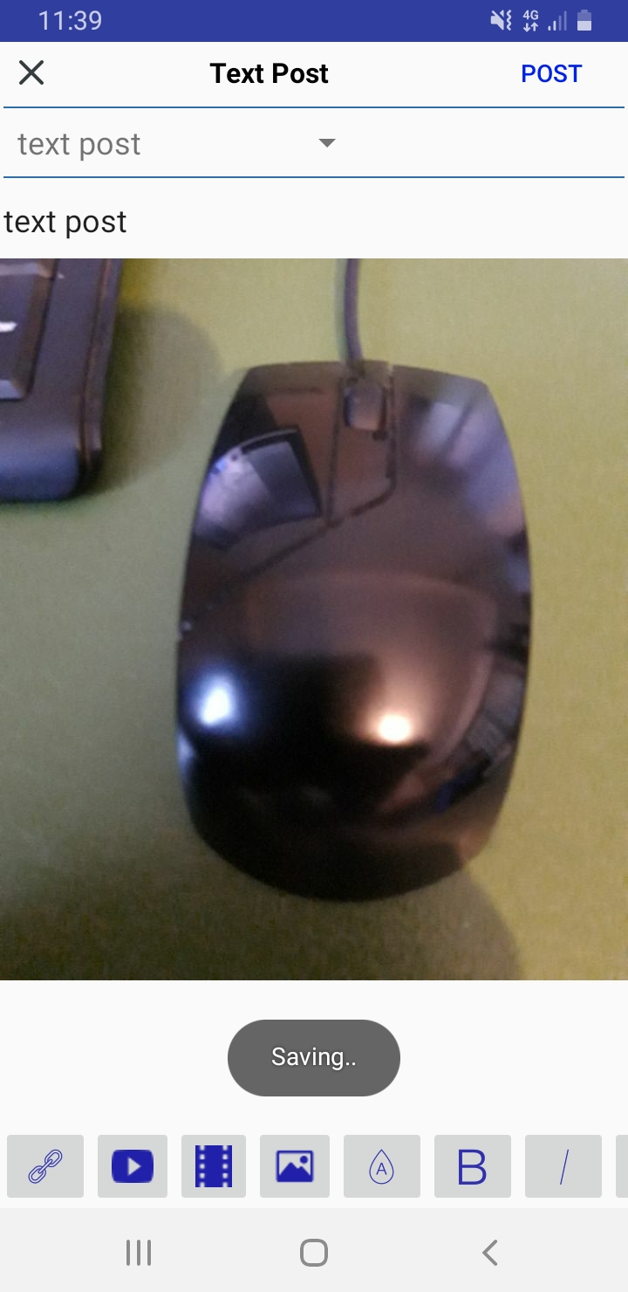

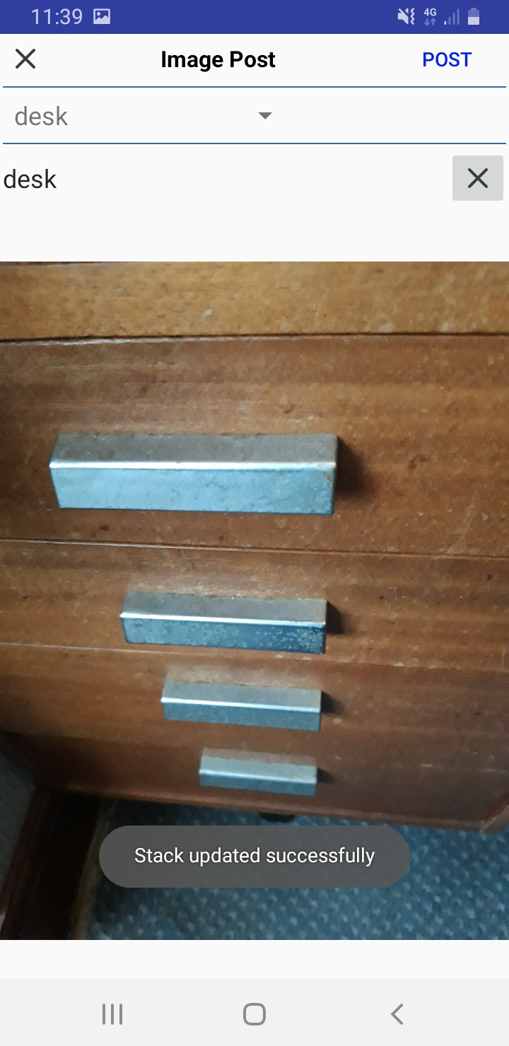

This is bug seven

Continuing from bug seven you should still be on the text post page because the preview button is not working so now you need to click the ‘POST’ button in the top right corner and your post will be published to the homepage of our app and you will be redirected back to the homepage. Now if you click to view your post from the homepage and click the first purple line it should load a page displaying the link you created instead it shows broken image and no link so this needs fixing, please see screenshot below:

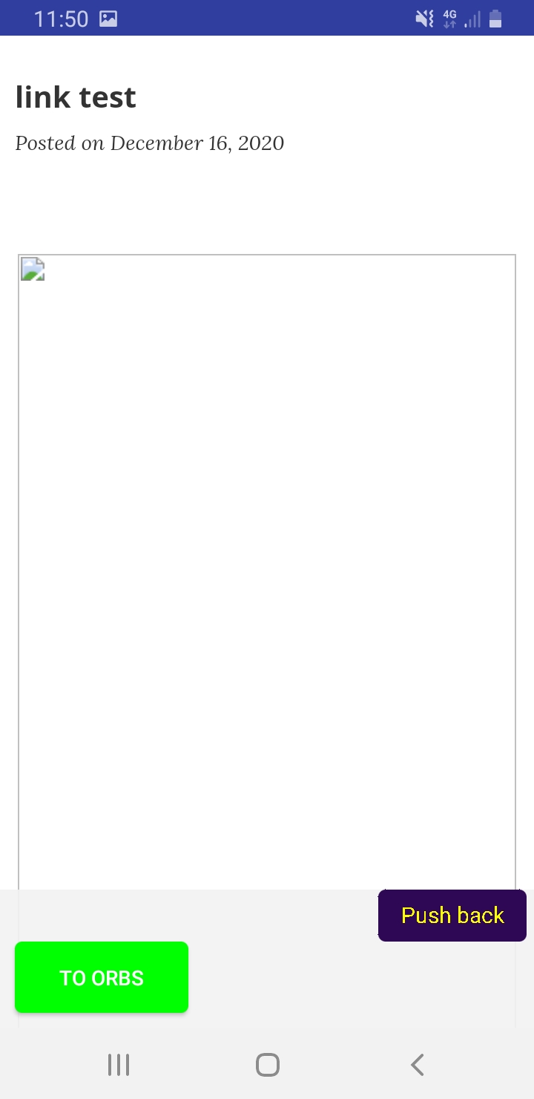

This is bug 8

If you click the ‘Push back’ button as shown in the screenshot above you will return back to the lines page, if you click the second line purple line that should display the image you uploaded earlier but currently it displays a broken image so this needs fixing so that it displays the correct image you upload, please see screenshot below:

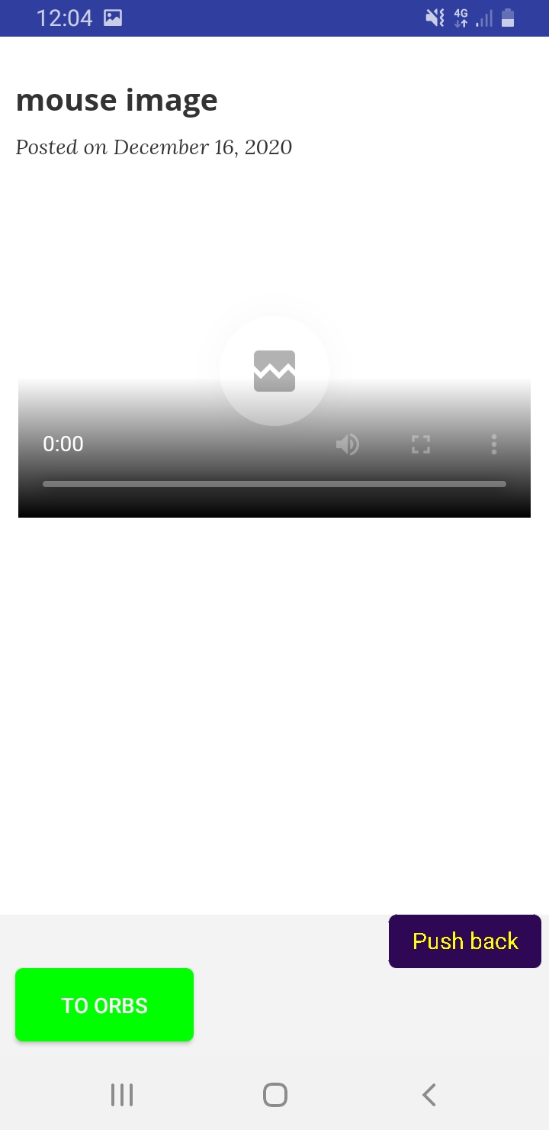

This is bug 9

If you now click the ‘Push back’ button again you will be redirected back to the lines page, we don’t need to click the third line because that is another image post and I have already explained what the issue is with image posts in bug 9.

So now you need to click the fourth purple line which should display and allow you to play the video you uploaded but currently it show blank white screen, please see screenshot below:

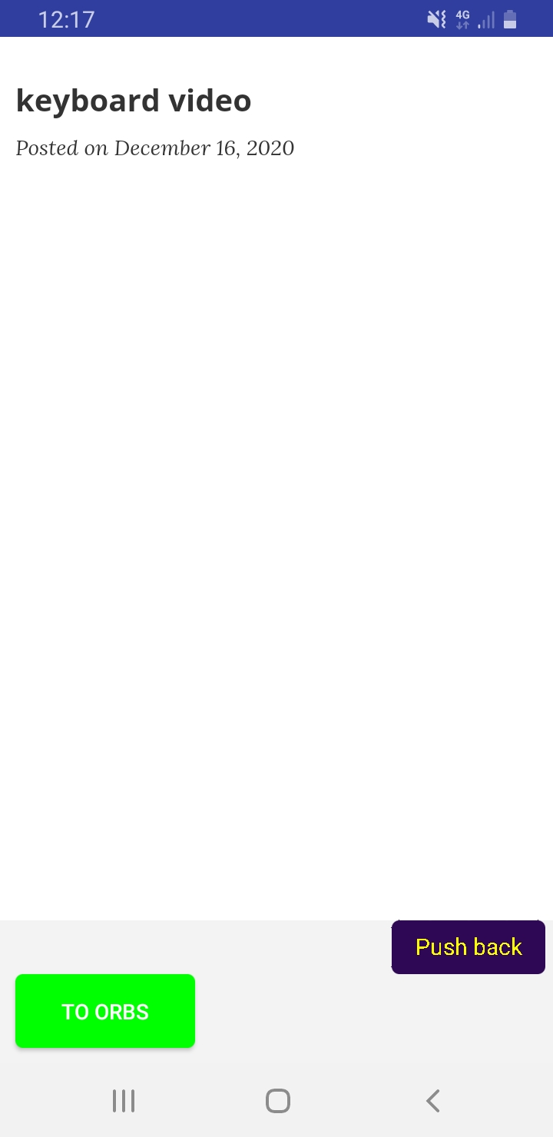

This is bug 10

Now if you click the ‘Push back’ button from the video page you will return back to the lines page and if you click the last line which is the text post you created, you will see that there is hardly any gap in between some of the images and videos you uploaded so please can you add appropriate spacing in between each uploaded item.

This is bug 11

Also if you scroll up and down on the text post page you will notice there is a grey bar at the bottom of the screen that moves up and down as you scroll, the issue with this bar is when you scroll right to the bottom of the text post page it overlaps the last image I uploaded so can you move this down so that the grey bar doesn’t overlap the last image. Please see screenshots below:
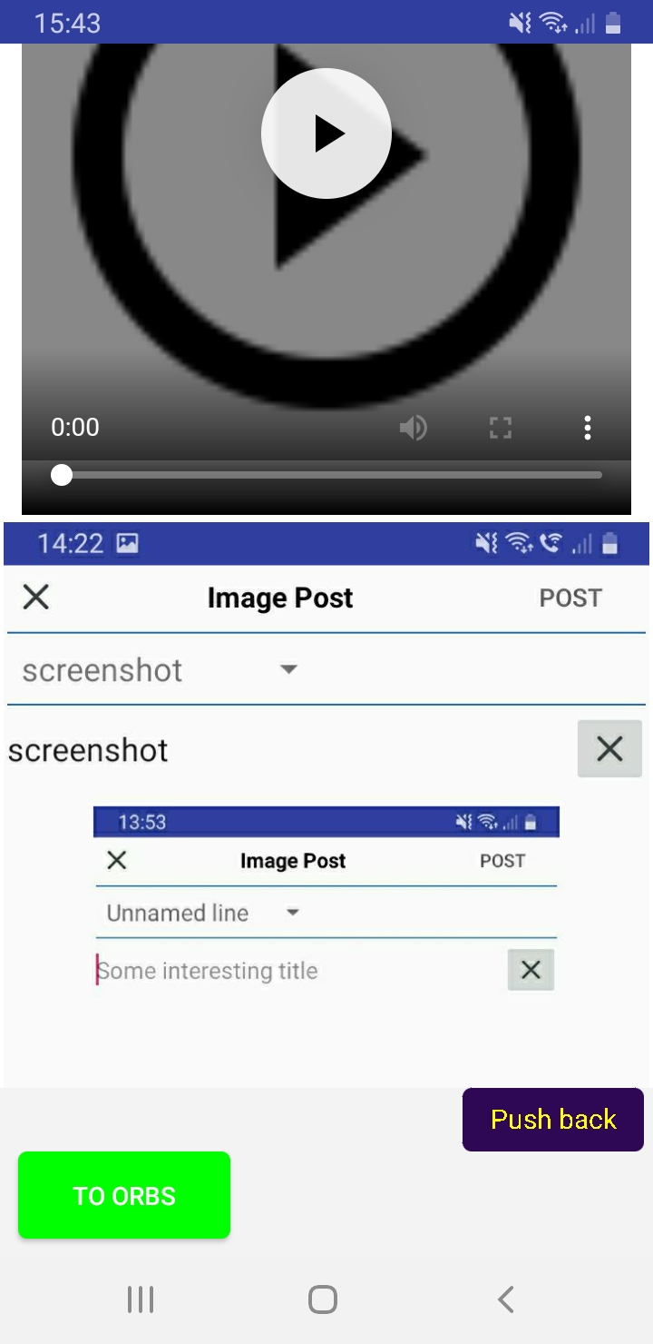
Move grey bar down so it doesn’t overlap image.
Add spacing here

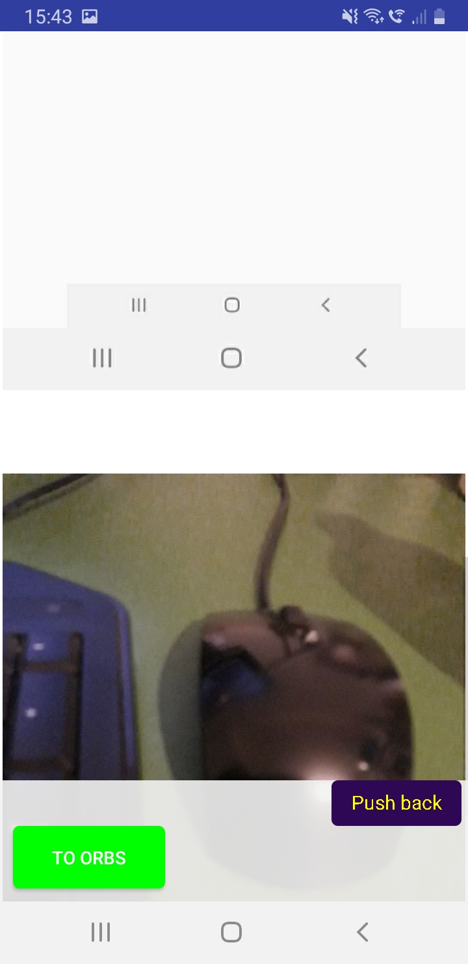
Add appropriate spacing this gap is too big.

This is bug 12

The steps i have explained from bug 3 to bug 12 must work across all different post types so these include ‘LINK’ ‘IMAGE’ ‘VIDEO’ and ‘TEXT’. If you read bug 3 we started by selecting a link post first and then adding an image, video and text post after but you must also be able to start with for example an image post first and then add a LINK, VIDEO and TEXT posts after and it should all still work properly regardless of what type of post you selected first.
-------------------------------

- Continuing from bug 12 if you click the ‘Push back’ button on the text post page you will return back to the lines page and then you need to click the ‘COLLAPSE’ button, you will then return back to the homepage where you need to select the pencil icon and ‘IMAGE’ post and insert an image and then enter a title and click arrow and enter a title then click ‘Save’ button becomes active but when you click ‘Save’ and click the avatar icon from the home page (top left) and click ‘Private stacks’ the stack saves but when you click it no data is saved no image or title so this needs to be fixed. This needs to be fixed for all type of posts so ‘IMAGE, LINK, VIDEO and TEXT’ when selected from the bottom.

This is bug 13

- We have a website that is connected to our app and vice versa, the issue is on the profile page on our website the user has an avatar but on our app when we login with this user no avatar is being displayed. See screenshot:

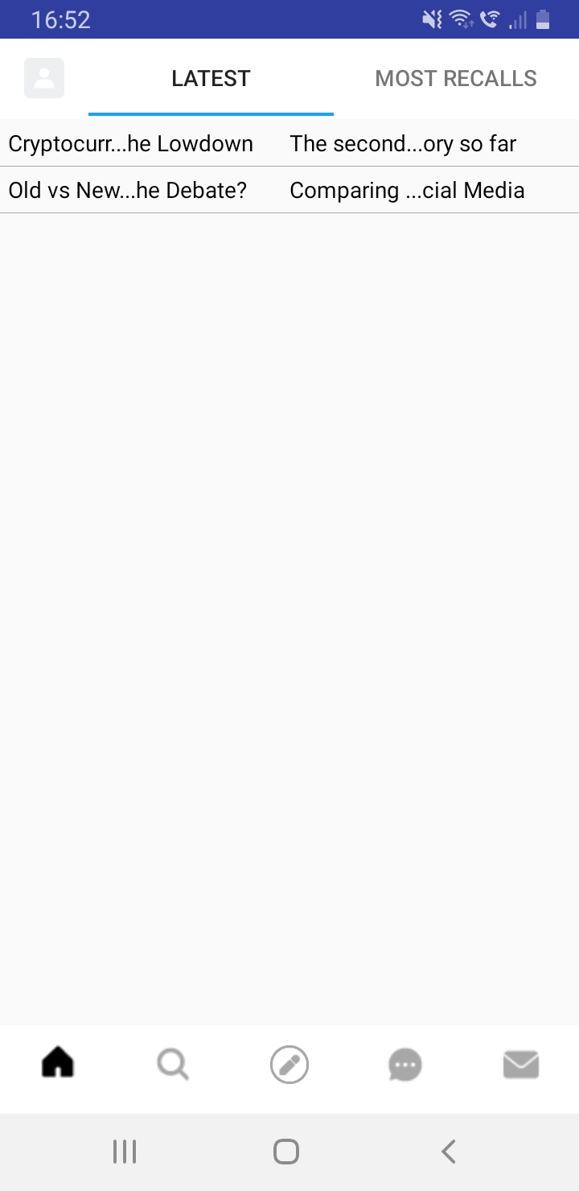

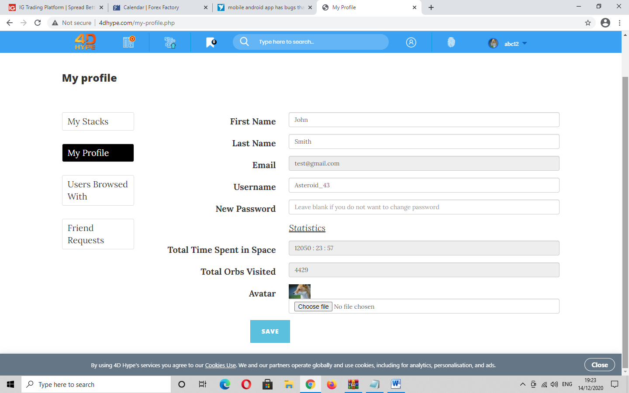
Here is the avatar displayed on our website. This same avatar should be displaying on our app too because we are logging in with the same user.

